Greetings,

I am Harsh Rai, a member of D10. My experience as a Softcom Club Coordinator, Mentor, and as part of the Inter IIT Tech Contingent (2024, 2025) has led me to this idea. Through these roles, I have closely observed how students, alumni, faculty, and visitors interact with the institute ecosystem in our college compared to others (IITB in this case). These observations highlighted several gaps in communication, onboarding, and long-term engagement.

This proposal is an attempt to address those gaps in a structured and scalable way, while also improving how the institute presents itself internally and externally.

INSTITUTE COMMUNITY APP
This idea originates from my experience at the Inter IIT Tech Meet 13.0 held at IIT Bombay. During the event, I observed how their “Insti” app played a crucial role in onboarding participants and visitors into the campus culture. The app was not merely informational but helped people understand how the institute functions as a living ecosystem.
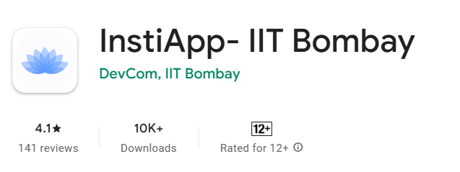imThe experience made it clear that a well-designed institute app can act as a bridge between people and the campus environment. It creates familiarity, reduces dependency on individuals for basic information, and leaves a strong first impression about the institution’s organization, culture, and values.

STAKEHOLDERS
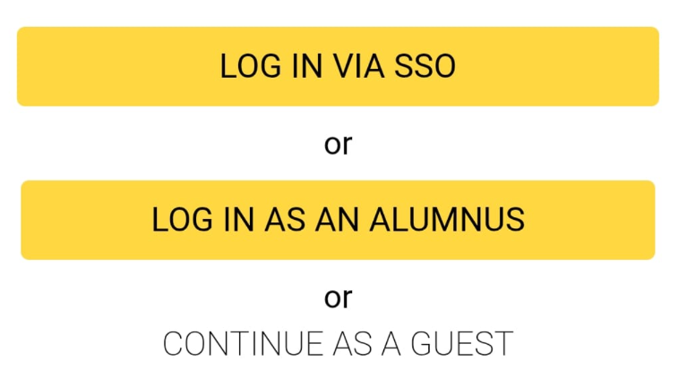

GUESTS
The primary beneficiaries of this app include guests such as visiting speakers, external faculty members, event visitors, and students coming for fests or competitions. While it is not feasible to provide these visitors with official email IDs or access to internal college portals, it is equally undesirable to leave them disconnected from the campus ecosystem during their stay.

Currently, no single faculty member, staff member, or student has the time or bandwidth to explain the entire college structure, culture, and activities in a short duration. The app fills this gap by offering a generalized feed, updates, and an ecosystem gallery that visitors can explore independently. This allows them to understand where they are, what happens on campus, and what the institute stands for.

Even if visitors do not grasp every detail, they develop admiration for the scale and quality of work being done by students, faculty, and alumni. While LinkedIn and Instagram pages cater to the general public, a dedicated app provides guests on campus with a far more immersive and focused experience tailored to their presence within the institute.
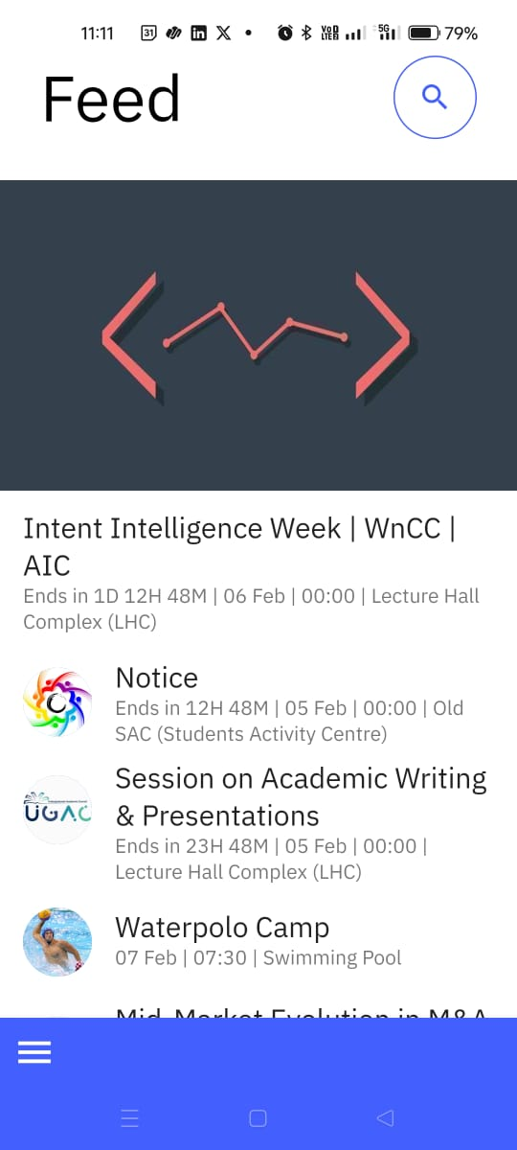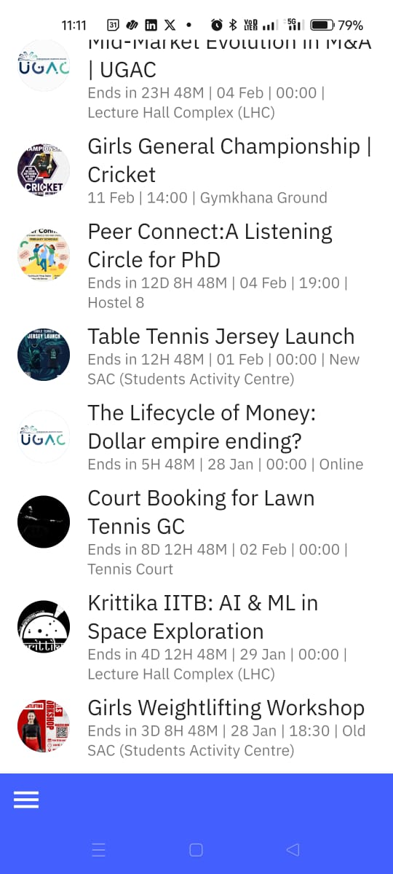
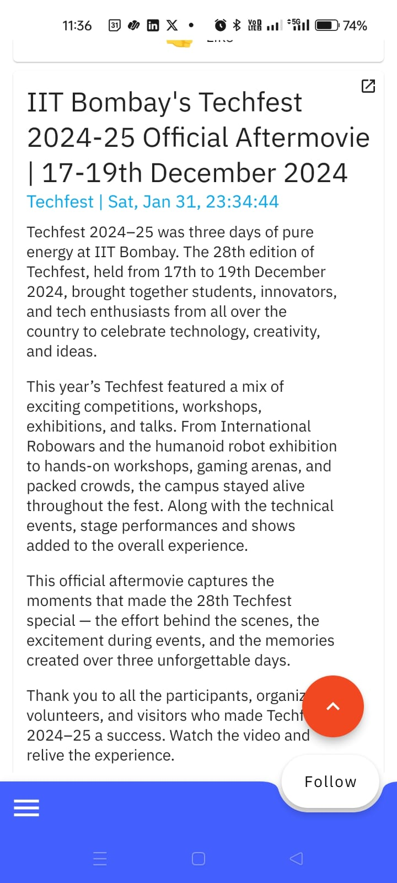

MAPS
A college-maintained map would be of immense value, especially considering that IIT Ropar is a rapidly expanding campus. As infrastructure grows, it will become increasingly impractical to explain the location and function of each building manually. A centralized digital map solves this problem in a sustainable manner.

The app can allow users to select their current location and set a destination to receive the shortest path. This is particularly helpful for visitors and newcomers who are unfamiliar with the campus layout and may hesitate to repeatedly ask for directions.

Why not Google Maps? Why a separate map?
While Google Maps works well for city-level and inter-campus navigation, it does not help us control how the campus is represented. An institute-specific map allows us to capture the beauty of the campus and present its story intentionally, rather than as generic coordinates.

Additionally, keeping every detail publicly accessible may not always be appropriate. Not everyone will download the app, but those who do will experience a curated view of the campus. We can also include detailed indoor maps for complex buildings like SAB, which is confusing even for people who have spent years on campus.
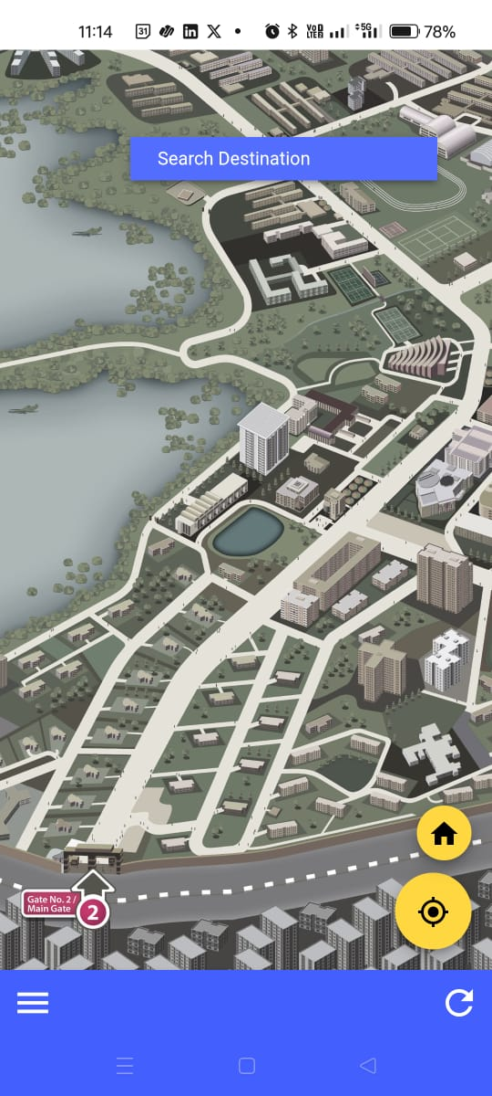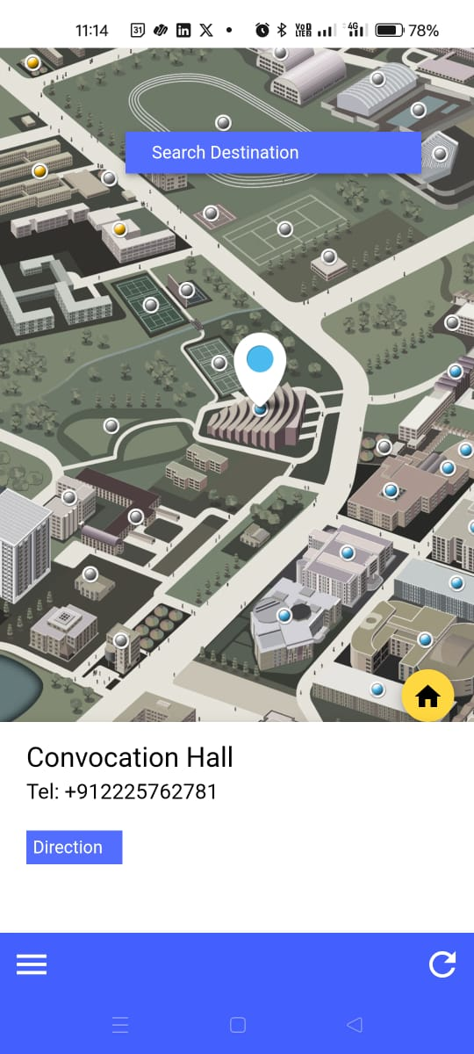

ALUMNI
At present, communication between alumni and students largely depends on LinkedIn, while official communication relies on emails. This fragmented approach makes it difficult to build a strong, emotionally connected community across generations.

Through this app, alumni can remain actively involved in campus life in a more personal and meaningful way. They can follow ongoing activities, share what they are working on if relevant, and engage with communities of interest. Unlike WhatsApp groups, which cannot scale to include everyone, a centralized platform can maintain inclusivity.

Alumni can message members of campus communities, plan meet-ups, and invite current students. Expecting alumni to constantly monitor LinkedIn posts, Instagram updates, or institute newsletters is unrealistic. A single app that aggregates everything makes engagement easier, more immersive, and emotionally sustaining.

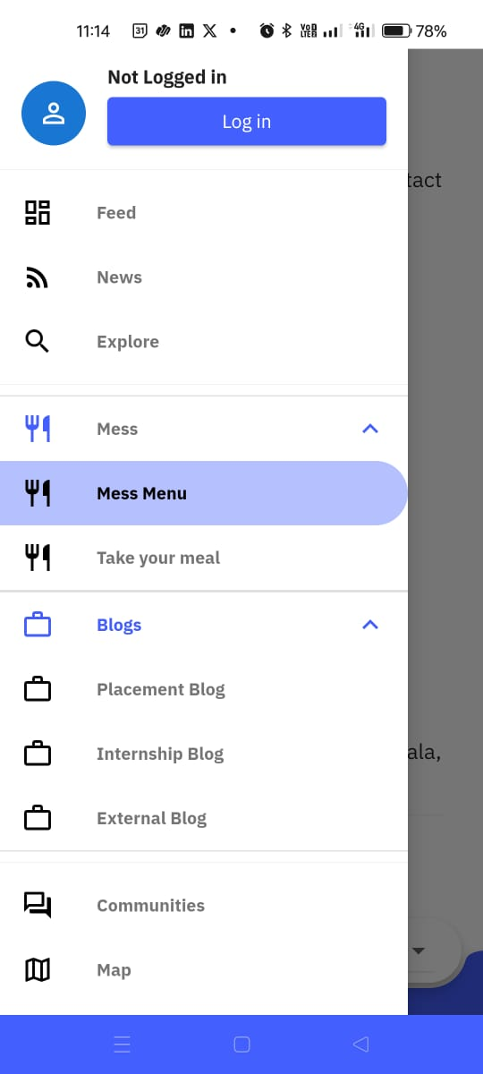

CURRENT COLLEGE STUDENTS, FACULTY, STAFF
Although current students gradually adapt to existing services and systems, this app still offers significant value to them. Several applications have already been developed under DEP and otherwise, but a unified platform that integrates all essential services creates a stronger sense of cohesion.

A central app changes how students interact with campus life. Instead of navigating multiple disconnected tools, students experience a single, consistent interface that reflects the institute’s identity and simplifies everyday interactions.

Key Utility Features
The app can support:
- Buy & Sell
- Lost & Found
- General notices
- and interest-based communities.

These are everyday needs that students currently fulfill through scattered WhatsApp groups or informal channels, which are inefficient and poorly organized. (Currently we have 2 broadcast groups because whatsapp has restriction on group size and Telegram can’t be used that formally for institute purpose - so I often have to ask from other friends in the other broadcast groups because each and every message isn’t fully shared)

By centralizing these utilities, the app reduces friction, improves visibility, and ensures that information reaches the right audience without unnecessary noise.

=> BLOGS
Blogs are the most effective medium for sharing detailed, thoughtful content. Platforms like email or WhatsApp are unsuitable for long-form communication, as not everyone wants frequent lengthy messages, and such content is hard to archive and revisit.

Blogs allow ideas and experiences to be documented permanently and accessed by anyone at the right time. They serve as a knowledge repository rather than a one-time broadcast.

i) Placement & Internship Blogs
As a third-year student, I have experienced the internship drive and will be facing placements next season. Students frequently ask seniors to share interview and online assessment experiences company-wise, which is not feasible to do individually.

Blogs allow these experiences to be shared once, clearly, and permanently. This benefits not only third- and fourth-year students but also first-year students, who gain realistic first-hand insights early in their college life. This helps them plan better without feeling hesitant about repeatedly approaching seniors for small details.

ii) Faculty Blogs
During a software course, Sodhi sir shared a blog discussing the impact of AI on software developers—how AI agents increase productivity but may reduce deep learning. It was a valuable read based on Claude research.

While reading it, the question arose: why should such insights be limited to a single class? Faculty blogs allow professors to share perspectives on careers, research, and industry trends with the entire student community. For example, Prof. Tamarapalli Venkatesh from IIT Guwahati highlighted declining student interest in research; blogs enable such insights to reach students at scale.

iii) Alumni Blogs
Alumni working in the US, major Indian firms, research labs, or those who have gained important life lessons can share their experiences similarly. They can even share some great shifts in industry so that students from our college are pre-prepared compared to masses. These blogs allow wisdom accumulated over years to be passed on to students in an accessible and lasting format.

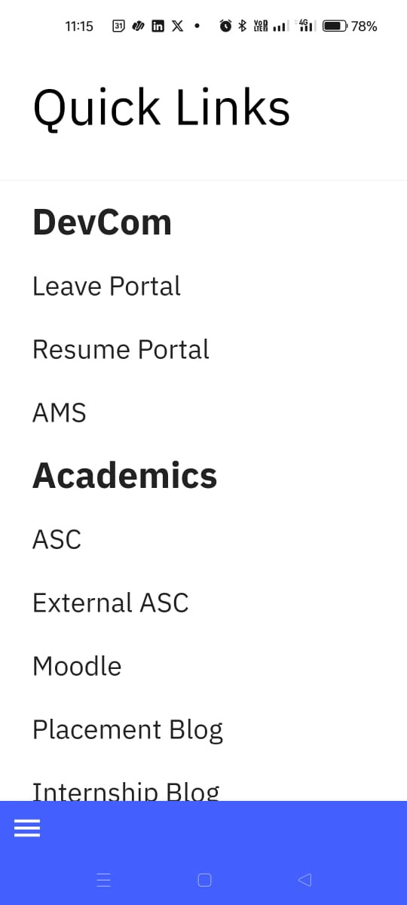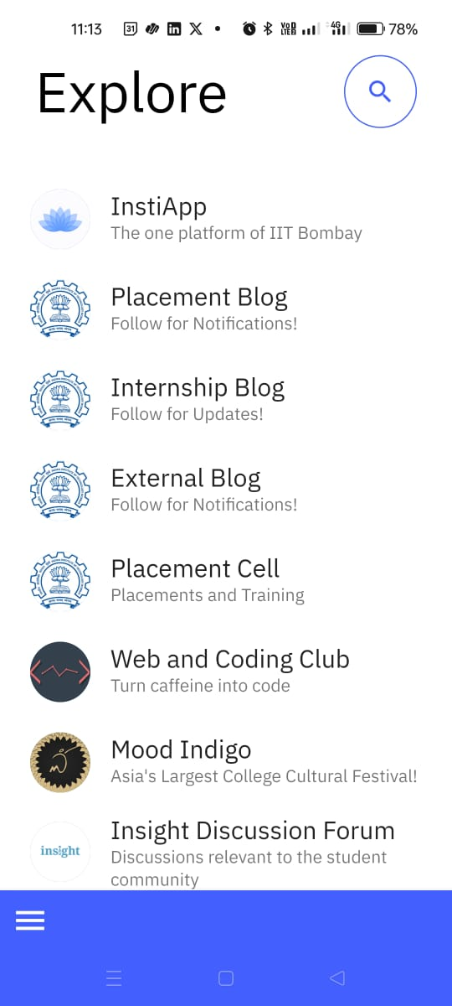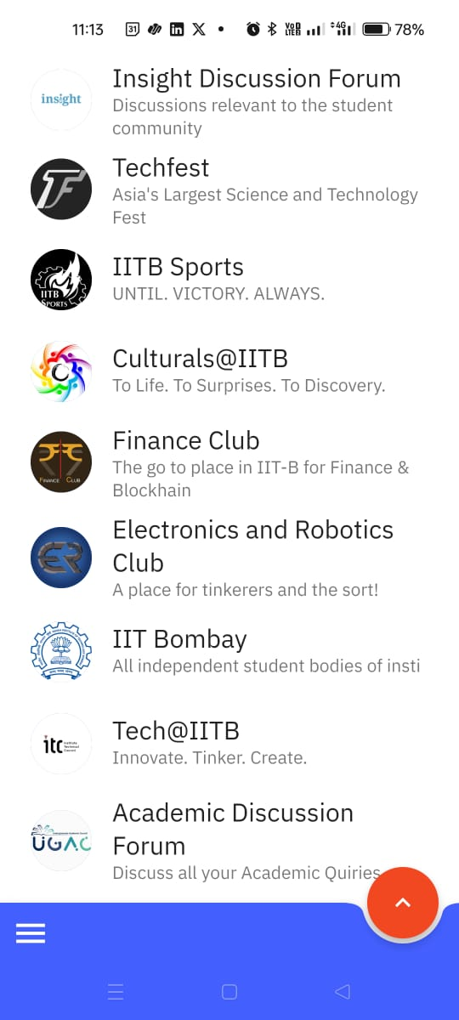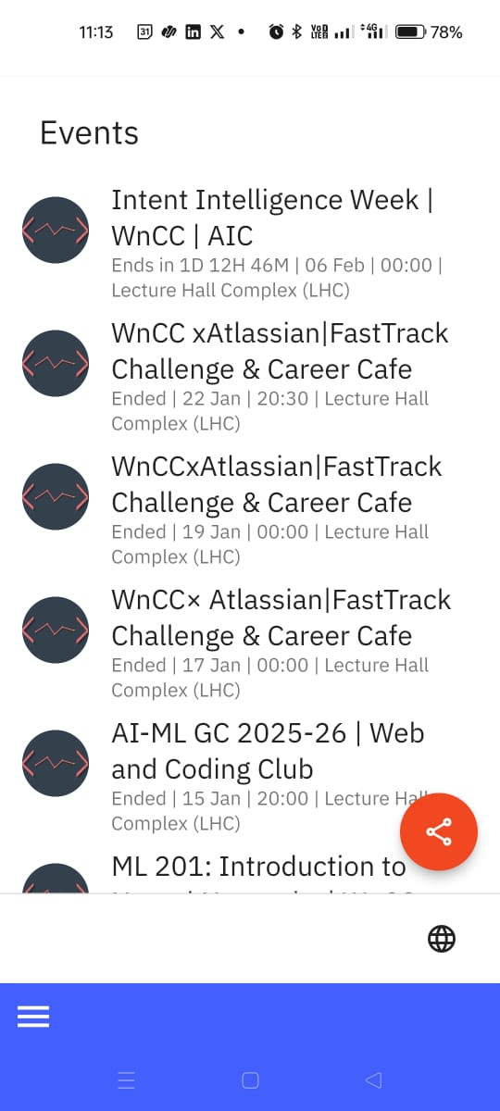

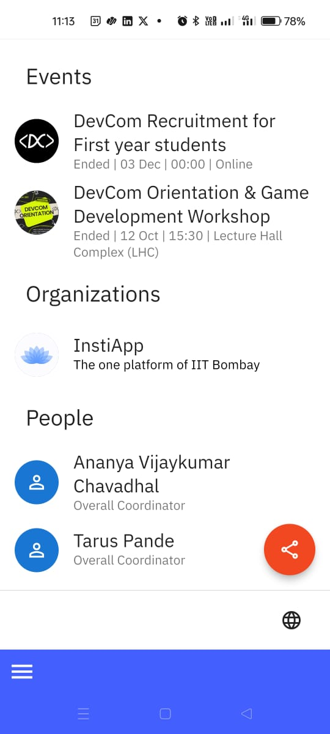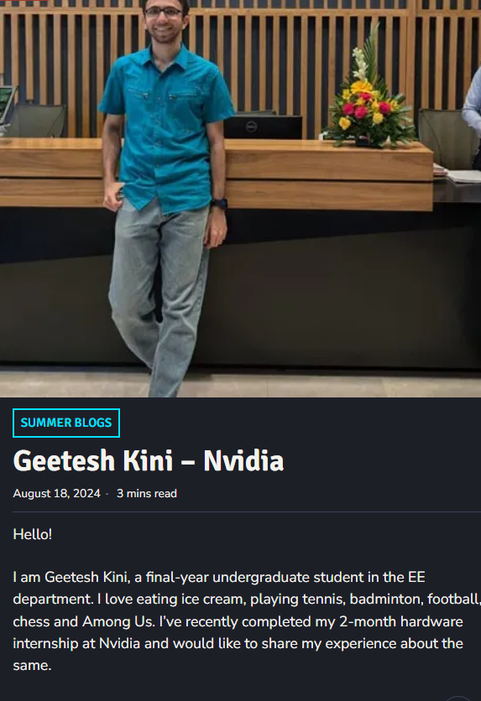

QUICK LINKS
There are numerous institute portals, and links are often scattered across different platforms. This app can consolidate all relevant links in one place, customized for different user groups such as BTech students, staff, and faculty.

By organizing these links contextually, the app reduces confusion and saves time, especially for new students and visitors unfamiliar with institute systems. All the bodies, and clubs under them with their description and recent events posted at one place - these formalize the ISMP process itself through an app. All the ISMP events can’t be attained by a person because one gets tired after a week of the induction process, & there this app will help with the onboarding experience.

The use case is quite broad & I can’t afford to write everything down but this app unites the fragmented culture/ecosystem of college in a way that can boost the efficiency to a level unimaginable from current positioning.

SoftCom, IIT Ropar can take responsibility for managing this app after the DEP, similar to how DevCom IIT Bombay currently operates or future DEP students can continue to scale this project. This ensures continuity, maintenance, and evolution of the platform beyond its initial development phase.

The core purpose of this app is to build deeper connections within the college ecosystem and to leave a strong, positive impression on visitors. It aims to foster a sense of belonging, continuity, and pride for everyone associated with the institute.

CONCLUSION:
I would be truly grateful for your consideration, sir. The fact that the app has crossed 10,000+ downloads clearly reflects its necessity and relevance as our IIT continues to grow and expand. Thank you for your time and attention.

PROBLEM ADDRESSED SUMMARIZED:
As IIT Ropar continues to grow in size, infrastructure, and community, the institute ecosystem has become spread across many platforms and informal channels. Students, alumni, faculty, staff, and visitors currently depend on WhatsApp groups, emails, LinkedIn, Instagram, scattered websites, and word of mouth for information and engagement. This results in weak onboarding, gaps in information, repeated dependence on individuals, poor alumni–student continuity, and an inconsistent external image when compared to more mature institutes such as IIT Bombay. There is no single institute-owned platform that brings together communication, culture, navigation, and long-term engagement in a structured and scalable way.

Institute-Level Gaps
- No unified digital identity: The institute does not have a single platform that clearly represents its culture, activities, and ecosystem for both internal members and visitors.
- Fragmented communication: Important updates and resources are spread across emails, WhatsApp broadcasts, Telegram groups, and websites, which often leads to missed or incomplete information.
- Limited scalability: Current informal systems do not scale well with increasing student strength, alumni numbers, visitor count, and campus expansion.

Guests and Visitors
- Poor onboarding experience: Visitors rely on individuals to understand the campus, its culture, and activities, which is not practical within a short visit.
- Lack of context: Social media pages are meant for the general public and do not provide a focused, campus-specific experience for guests who are physically present.

Campus Navigation
- No institute-managed map: Rapid campus expansion makes manual guidance difficult, especially for new students and visitors.
- Limits of generic tools: Google Maps does not allow controlled presentation, indoor navigation, or storytelling of the campus.

Alumni Engagement
- Disconnected interaction: Alumni communication is mostly limited to LinkedIn and emails, leading to weak emotional and professional continuity.
- Low long-term engagement: Alumni cannot realistically track institute activity across many platforms, which causes gradual disengagement.

Students, Faculty, and Staff
- Scattered daily utilities: Buy & Sell, Lost & Found, notices, and communities are handled through informal and inefficient channels.
- Information loss during induction: ISMP and onboarding activities are intense and temporary, with no lasting digital companion to explore institute bodies and events later.

Knowledge and Experience Loss (Blogs)
- No permanent repository: Placement experiences, faculty insights, and alumni learnings are shared informally and fade with time.
- Limited reach and reuse: Valuable experiences do not reach all students or future batches in a structured, searchable, and scalable form.

